DUNAREA de JOS UNIVERSITY of GALATI INVOLVEMENT in the VOCATIONAL TRAINING PLATFORM DEVELOPMENT:
LdV – EMOP PROJECT

SL Drd. Eng. Mihaela IORDACHESCU
Assoc. Prof. Dr. Eng. Elena SCUTELNICU
Assoc. Prof. Dr. Daniela SARPE
Dunarea de Jos University of Galati, Romania

- Introduction

The impact of the Information Society (IS) on education, culture, economy and worldwide trade has been analysed in the context of the European Commission after the year 2000, setting up precise objectives for the future development of specific infrastructures and measurements, necessary for a well-balanced IS implementation.
Consequently, lifelong education has evolved into an important part of the Romanian policy, targeting on improving the quality and encouraging full access to continuing, vocational training and permanent acquirement of aptitudes and abilities, thus developing one’s adapting capacity as well as supporting technological and organizational changes. Hence, continuing education grounds itself on ensuring labour building/adapting at the high standards imposed by the information society, while one of essential instruments of implementation is the Leonardo da Vinci Program.
One of the Leonardo da Vinci Program’s three framework-objectives is improving the quality and encouraging full access to continuing, vocational training and permanent acquirement of aptitudes and abilities, thus developing one’s adapting capacity as well as supporting technological and organizational changes.
Some aspects aim at the identification, evaluation and recognition of the non-formal and informal learning, as well as at the transfer and mutual recognition of certificates and official diplomas. Furthermore, all forms of educational and vocational learning, leisure or familial activities should be identified, evaluated and acknowledged accordingly, targeting at allowing citizens to develop and combine these different forms of learning.
The EMOP project (Empowering Employees to Manage their Outplacement Process), that will be finalized in November 2005, is one of the Leonardo da Vinci projects in which Dunarea de Jos University of Galati is involved. This project has a special impact on the local labour market and aims the development of an innovative outplacement concept in order to improve the people’s capacity to adapt to the market needs. Romanian version of the final product is applied, especially, to the people engaged in the metallurgical industry, which are not content of their job or search another job. In this paper, some details about project, description of the preliminary version of the vocational platform which allows communication “face to face” and at distance (chat, mail), are presented. An important aspect is connected to the addressability, at any level, of the final product which is utile for all those who understood the necessity of change in order to adapt to the market needs. The new instrument, provided by EMOP, serves as interactive communication platform between client and outplacement consultant and promotes the individual self management. In addition the instrument can be used not only reactively in dismissal situations, but also preventive/actively for the job search. In particular it can serve placement officers in public institutions (labour office) substantially for appropriate, efficient and transparent organization of their advisory achievement.

- EMOP project’ presentation

Aim of the project
The aim of the EMOP - project is the development and the practical use of an innovative outplacement concept in all partner countries: Germany (the project’ promoter), Italy, Greece, Spain, Portugal, Poland, Czech Republic, Romania. The new concept is characterized by the following specifics:
- Combination of personal, face-to-face and internet-based support of participants in a vocational re-orientation phase;
- Educative approach: new methods of teaching and learning accompanying the re-orientation process with the goal to qualify people for their own job-search, respectively successful placement on the job market by teaching them methods to preserve their working abilities;
- Double functionality of the Internet tutorial system: Self organization and communication platform for the participant – Case-organization and administrative platform for the advisor;
- Useable on various educational levels (only condition is basic IT-knowledge);
- Reactive use in urgent cases of outplacement; proactive use as qualification for a later job search;
- Comparability and possibility of international use in the countries of the European project partners: Standardized basic version, country- and target-group-specific adaptations.
The goal is, to create a European partner network by the development of a common instrument with country-specific versions. Thus industry-specific developments of the job market in different countries become transparent at an early stage.

Internet-based support and self organization of the participants
The EMOP - tutorial system contains two complementary sets of modules, one set for the respective participant, one set for the advisor.
Modules for the participant
- Mastering of involuntary changes of situations (selected psychological literature as well as working material to be worked on in asynchronous interaction with the coach)
- Analysis of career potentials – assessment of working and social skills (introduction and test sheets). In the German version for example, the BIB inventory will be used.
- Training the job application procedures (basics, model CVs and cover letters, etc.)
- Individualized information about enterprises and industry
- Personal organizer for organizing application dates, interview dates, documents etc.
- Communication forum/chat for exchanging news and tips with people in similar situations.
- Links to job-searching sites in the Internet, links to interesting sites differentiated by target-group-specific interests.
Administration and documentation functions for the advisor
The individualized user-surface on the side of the participant does have a supplement on the advisors side, which serves as case-managing and general administrative surface. The advisor supports the participants thus by:

- Supplying with working material;
- Analysis of career potential (see above): feedback results, suggestions for further training, etc.
- Feedbacks on personal application documents;
- Supplying with individualized information about enterprises and industries;
- Support of necessary actions in the application process.
The EMOP - system provides the advisor automatically or manually memory functions (e.g. reminder for phone calls before job interviews etc.). The administrative surfaces on the advisor’s side make it possible to show on one hand a case overview and an organisational structure of all cases worked on at present on the other hand. The system serves thereby as interaction, administration and organizing platform for the advisor. The asynchronous, distance interaction for the participant is complemented by advice by telephone or personal consultation. The attention of the advisor is not strictly focussed on a direct placement of the participant in a new job. He rather concentrates on helping people to learn a new application strategy. This process enables the participants to cope with changing situations and to develop an individual constructive change management, a knowledge which the individuals can activate also in similar situations in their future life.

Results and Impact

Character of the results
- Innovative, ready-to-apply method of the outplacement consultation
With EMOP, a new, ready-to-apply method of the outplacement consultation will be developed. The innovation consists of
- the combination of the – in comparison to the conventional form – reduced number of advisor interviews and instead internet-based distance-support of the participants;
- an educative approach, which pursues the knowledge transfer of methods and abilities for a successful accomplishment of vocational change requirements for the individual;
- the possibility, to use it both proactively, that is as interdisciplinary educational training in the context of lifelong learning, and reactively, in acute outplacement situations.
- Advisor training, manuals for advisors and participants
To guarantee the quality of the appliance and to enable the independent use, multipliers will be provided with detailed instructions (e.g. manuals) for advisors as well as for participants. Furthermore an advisor-training will be developed. The training is accomplished before the pilot phase within the partnership.
- Generic basic version and individually shaped versions for different countries, languages and target groups
The tutorial system will consist of a generic basic version, which is developed by all partners together. All of the partners with a specific demand will implement on this structure their own individually shaped version. For example in Romania, the basic version will be applied in the metallurgical industry in Galati city where is located the largest European metallurgical factory (ISPATSIDEX) and the mass dismissal is stipulated.
- Material for European comparison over vocational training and consulting processes
Because of the standardized basic version developed in all countries the advisor training EMOP offers an ideal starting position for the scientific comparability of the results. The results of the pilot tests – accomplishment of loss of one's job, proactive acquisition of new abilities to the individual change management, individual strategies for the re-orientation, duration of the job search – are evaluated and documented accordingly.

Impact
EMOP will enable enterprises to offer active support to employees, who will be dismissed due to rationalization. By replacing a certain amount of costly face-to-face meetings between outplacement coaches and outplacement candidates with decentralized, continuous internet-supported monitoring, more employees, in particular of lower and middle hierarchy levels, can be taken care of. EMOP strikes thereby a bridge between enterprises and workers' delegates. It offers an instrument to take up social responsibility for employees facing dismissal. Additionally, this caring attitude has positive effects on other employees remaining in the enterprise.
The EMOP instrument serves two purposes: firstly of all re-actively, supporting outplacement candidates in coping with acute outplacement situations. Secondly, incorporated in regular vocational trainings and study programs, it provides the above mentioned skills for future job-hunting challenges. This educative approach teaches a methodology and abilities, which will be useful to participants not only in their present situation, but also in future working life. Hence, the long-term effects of the measures are being promoted.

Vocational training platform development
The web site of the project including functionalities – available for all partner members - such as administrative issues (file database, logos, board usage), basic version (file database, functionalities and requirements, technical requirements), country-specific versions (file database) and personal communication is presented in the figures from below.
The generic basic version, translated into the all partner countries languages, will contain two separated areas, for the EMOP client and also for the coach. The functionalities planned to be included in the Client Area are the Personal Desktop, Organizer, Help, Profile, Library, Notes and Overview. For the Personal Desktop, the client will be able to define what to be displayed on the welcome page. The Organizer page will contain the calendar, e-mail and address book. The each function or module within the client area a context related Help text will be available. Additional help should be delivered through a support forum and/or a Knowledge Base System. The Profile function enables the user to change his/her personal and access data. In the Library module the list of available materials will be determined by each candidate’s matching profile code, the access complete or partial at each document depending on the document type. Every client will be able to take personal Notes at any time during his/her visit of EMOP. These notes can be saved, printed and dismissed. The Overview function gives to the candidate a quick overview of new messages, documents and the last visit in the client area. All information in the overview will be linked, so the client has quick access to the related modules and/or tools.
The Coach Area will contain the following modules: Personal Desktop, Overview, Process Minutes, Organizer, Group Management, Document Management and Action System. The Personal Desktop page will be the welcome page of the coach, having the same information type like in the client’s case. The Overview function gives the possibility to the coach to see, quickly, the new mails, last visit. The coach has also a quick access to the related modules and/or tools. Every item in these lists will be marked with its priority and status. In addition, the coach will find here a list (ordered by name, company, group) of the candidates he/she is responsible for. The Process Minutes functionality allows to the coach a quick overview about each candidate’s current status in the process, number and sort of actions within each module for each candidate. So, the coach will be able to recognize gaps in the action taken by single candidates and to oversee the outplacement process.

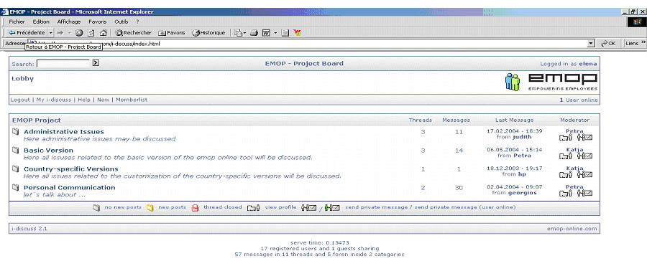

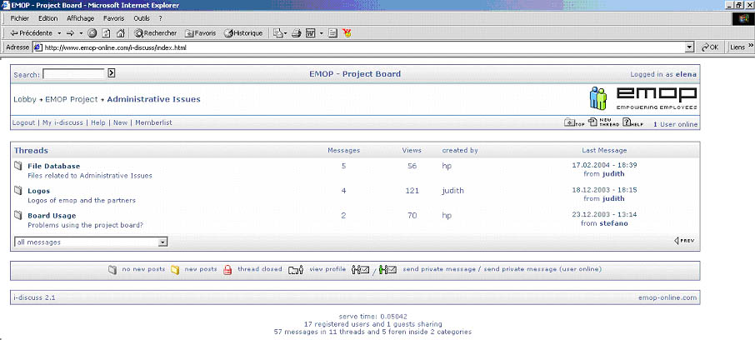

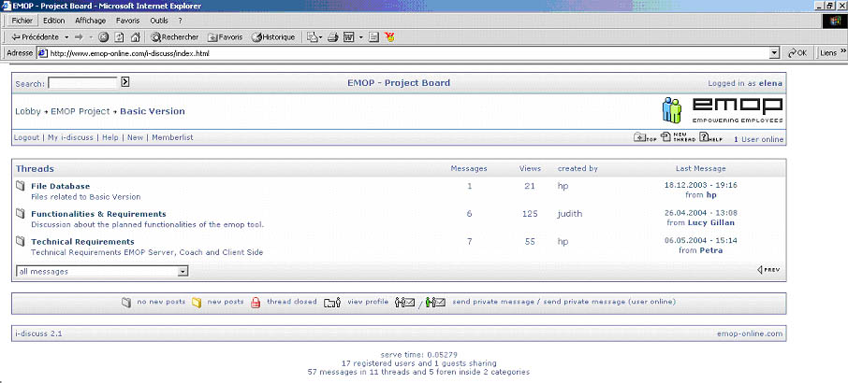

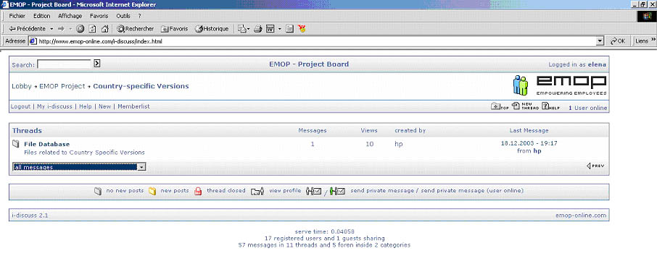

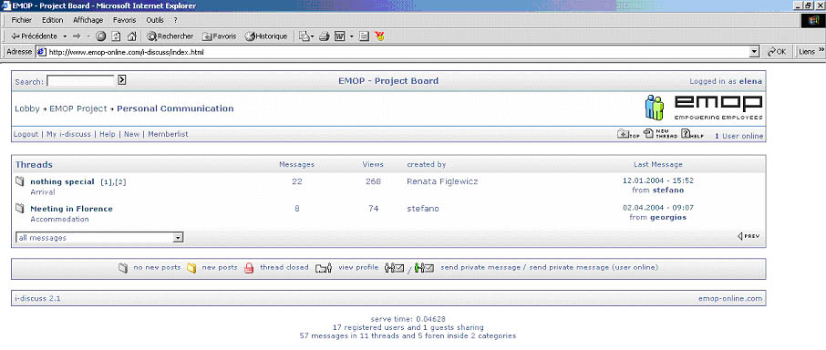

According to the client’s organizer the coach’s Organizer also contains a calendar, e-mail and address book, but the functionalities vary from that of the client because the coach will be able to post entries to the candidate’s calendars and to switch between own calendar – own activities, single client calendar and related activities or group related calendar and activities. The Group Management’ function will enable the coach to define groups of users on every level. This allows a high flexibility in the handling of actions within the system. In the Document Management module, the coach will be able to upload and categorize documents such as Word Documents, Text Files, Pictures, Flash Pages and so on. Documents will be stored in the database using a free definable folder structure. The Action System will be used to generate automated, named and combinable workflows.

- Conclusions

The EMOP project develops an innovative outplacement-concept which presents some specific aspects such as: contribution for the introduction of changes in the national systems of vocational training and – practices, contribution to the European strategies for the vocational training, combination of new applications strategies with existing methods, instruments and products in order to use them for new topics and/or target groups, new ways of co-operation/networking between partner institutions and/or political decision makers.

References

- Iordachescu M. – General Overview of the Statistical Indicators Benchmarking Labour Force in Galati County and South-East Development Region of Romania, First report: Actual Study of Unemployment in Galati County, January, 2004.
- 1st General Meeting: Discussions & Conclusions – Bonn, Germany, November 2003.
- http://www.emop-online.com – The LdV - EMOP project’ web site.

